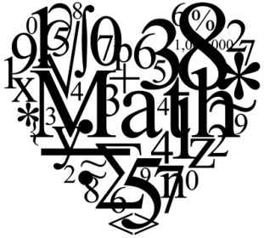
Honors Math 7 Syllabus
Teacher: Alex Harris
Email: alexandreas.harris@cms.k12.nc.us
Jay M. Robinson 980-343-6944

Welcome to Honors Math 7! To best prepare students for Math I in 8th grade, students will be learning Math 8 curriculum in this course. Our goal is to ultimately prepare students for success in college, build upon mastered algebra and numeric concepts, develop problem solving skills, and understand practical applications of math in our everyday lives. To achieve this goal, we will utilize the following activities:
- Using problem solving skills
Tutoring
By Request Thursday from 7:15 AM-7:45 AM

- Utilizing critical thinking skills
- Completing projects
- Focusing on math vocabulary identified in problems
- Working independently
- Working in groups

Wish List Supplies (For the classroom)
- Tissues, Tissues, Tissues
- Expo markers
- Paper towels
- Disinfecting wipes
- Bright colored printer paper

Required Supplies
- 1 Three Subject Notebook OR 3 One Subject Notebooks
- Pencils
- Graph Paper
- Ti-83, Ti-83 Plus, Ti-84 calculator

CMS Grading Scale & Distribution  A 90-100  B 80-89  C 70-79  D 60-69  F Below 60 | Classroom Assignment Weight  Formal Assignments 65%  Informal Assignments 35%

Homework Grading Scale

Weekly homework assignments will be given to students. The homework will be assigned on the last day of the week and due the last day of the following week. Additional assignments may be given on an as needed basis.
Most assignments will be posted online. Homework will be graded based on completion and correctness. Points will be deducted if homework is late or incomplete. Complete work neatly: copy original problems, show ALL work to justify answers, and indicate final answers

Signatures are due by Friday, September 1, 2017

______________________________________ ______________________________________
Student Signature Parent Signature

